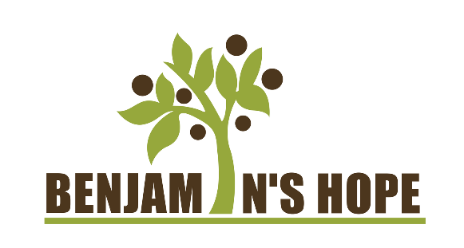

Direct Care Worker (Sidekick)

Benjamin’s Hope was founded on the belief that every person should have a community and place they call home where they can feel valued and cared for. As an adult foster care nonprofit organization, we provide a person-centered approach through the way we care for our residents and create meaningful work for our employees. Our “Live, Learn, Play, Worship” model inspires our staff and residents to grow closer in a faith community by experiencing the joy of doing life together. We have 6 independently licensed homes located on our beautiful, 52-acre campus in Holland, MI, where our residents and employees are able to enjoy the beauty of nature in a large space.

Our greatest resource is our people, which is why we are seeking multiple Direct Care Workers (Sidekicks) to build meaningful relationships with our residents and assist them in their daily activities. Whether it is preparing meals, doing laundry, or just sitting and chatting, you will get the chance to provide compassionate support to enrich the lives of many individuals in a growing community. We are a fun and supportive group of individuals who love what we do and are excited to continue expanding our team.

The meaningful work that you will do:
- Provide hands-on assistance to our residents in their daily activities including hygiene and personal care, cooking, and cleaning, and administering medications and treatments in accordance with doctor’s orders
- Maintain proper records and documentation for each shift
- Act as an encourager and motivator for our residents through helping them participate in activities and community events
- Assist our team in facilitating community events, outings, and scheduled programming for our residents
- Interact with family members of our residents and provide professional and helpful support when needed
- Work to ensure all policies, procedures, rules and regulations are being followed

You make a great direct care worker if:
- You are at least 18 years old.
- You hold a high school diploma.
- You can work consistent shifts that include weekends and holidays.
- You excel in working independently but also have a team player mindset.
- You are compassionate, resilient, and have a caring heart.
- You have passion and belief in our mission of empowering and supporting adults with developmental disabilities.
- You are able to lift up to 50 pounds.

Why us? Here are some benefits and perks that we will offer you:
- $17.20-19.20 hourly rate with shift premiums and other incentives – you will be appreciated here!
- Paid training – we pay you while we train you
- Health insurance
- 401k match
- A supportive and nurturing team
- A diverse and enriching community
- Monthly cell phone stipend
- Length of service bonus

We are hiring for three shifts:
- 6 am to 2 pm
- 2 pm to 10 pm
- 10 pm to 6 am

Full-time and part-time positions are available.

If you want a role that impacts lives of residents and families and a career that makes a difference, come join our growing team! Apply now!

